SPRING HILL MEDICAL CENTRE
NEWS LETTER
March 2018 EDITION

Urgent and emergency care services in England

When to dial 999: responding to emergencies
At some point, most people will either witness or be involved in an Accident or experience a medical emergency. Knowing what to do next and who to call can potentially save lives.

Life-threatening emergencies
Call 999 in a medical emergency – when someone is seriously ill or injured and their life is at risk.
Medical emergencies can include:
- loss of consciousness
- an acute confused state
- fits that are not stopping
- persistent, severe chest pain
- breathing difficulties
- severe bleeding that cannot be stopped
- severe allergic reactions
- severe burns or scalds
Call 999 immediately if you or someone else is having a heart attack or stroke. Every second counts with these conditions. Also call 999 if you think someone has had a major trauma. Major trauma is often the result of a serious road traffic accident, a stabbing, a shooting, a fall from height, or a serious head injury.

This practice is rated
GOOD
By CQC
March 2018
NEW from January 2018
CENTRAL NUNEATON
Blood Test Clinic
Newtown Centre,
Newtown Road, Nuneaton
Book an appointment online at www.geh.nhs.uk
or call 024 7615 3546

SPRING HILL MEDICAL CENTRE
NEWS LETTER
March 2018 EDITION

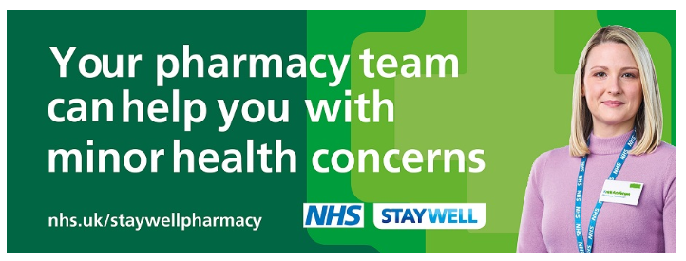
Due to the large number of patients failing to keep appointments, in particular
Pre bookable web appointments

The practice has introduced a policy whereby if patients fail to attend their appointment 3 times they will no longer be able to pre book via patient services and will have to re-register for this service.

Are you a Carer? Can we support you?

Carer's Café & Carer Support Network
1.30pm - 3.30pm First Tuesday of EVERY month
Contact 024 7686 5441 for more information. Held at the Warren, Mary Ann Evans Hospice, Eliot Way, NUNEATON, CV10 7QL

Other patients want your appointment!
If you need to cancel your appointment within
24 hours please email:
cancelmyappointment24@springhillmc.nhs.uk

