SPRING HILL MEDICAL CENTRE
NEWS LETTER
JULY 2018 EDITION
**DO NOT REQUEST A HOME VISIT VIA EMAIL**

Home Visits
Please telephone 01676 540395 option 1 before 10.30am if you require a home visit.
Home visits are for patients who are too ill to come to the surgery. The doctor can see three or four patients in surgery in the time it takes to do one home visit.
The surgery contains better facilities for examination and treatment than are available in your home, so it is better to come to the surgery if at all possible.
In order to help the doctor, brief details of the illness is required in order to deal with your request appropriately.
The doctor may telephone you beforehand to discuss the visit.

IMPORTANT PATIENT INFORMATION:
Core Opening Hours - Spring Hill Medical Centre
Monday 08:30 - 12:30, 13:30 - 18:30
Tuesday 08:30 - 12:30, 13:30 - 18:30
Wednesday 08:30 - 12:30, 13:30 - 18:30
Thursday 08:30 - 12:30, 13:30 - 18:30
Friday 08:30 - 12:30, 13:30 - 18:30
Each day the phones are switched to emergency service at 17.30. When the surgery is closed at 18.30, patients must contact NHS 111 by calling the telephone number 111.
The Practice Secretaries are available between 1.30pm and 4pm Monday to Friday.

Cancel My Appointment

If you need to cancel your appointment within 24 hours please email:
cancelmyappointment24@springhillmc.nhs.uk
SPRING HILL MEDICAL CENTRE
NEWS LETTER
July 2018 EDITION
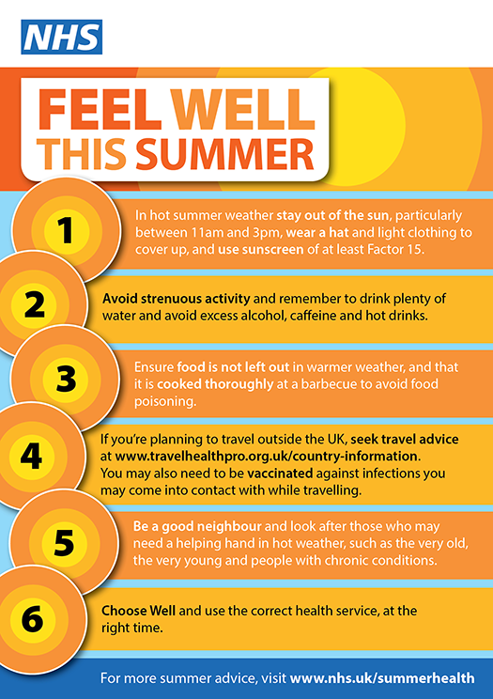

NEW from January 2018
CENTRAL NUNEATON
Blood Test Clinic
Newtown Centre,
Newtown Road, Nuneaton
Book an appointment online at www.geh.nhs.uk
or call 024 7615 3546

Fight the Flu with Spring Hill

