SPRING HILL MEDICAL CENTRE
NEWS LETTER
OCTOBER 2019 EDITION

23rd November 2019*  SATURDAY FREE  WALK IN FLU CLINIC | 9.30am to 2.30pm | Spring Hill
* Applies to patients who are OVER 65’s OR on an “at risk register” e.g. diabetic, COPD, Chronic heart disease, pregnant woman, immunosuppressant and carers. From 18 to 64 years on an “at risk register”. Under 18 years please book an appointment with the Nurse for nasal flu from 20th October 2019.
Telephone Triage Appointment System
We are here to improve access to help you.

How does it work?
This may be appropriate in cases when patients wish to discuss blood results, hospital letters or X ray/scan results. However if the patient needs to come in then an appointment will be made with the appropriate healthcare professional be it a GP, Practice Nurse or Healthcare Assistant.

Any patient who requests a Doctor’s appointment will receive a phone call from the Doctor. The doctor, after speaking to patients decides to either bring them in to an emergency clinic set up precisely for that purpose on the day or book them in to be seen on another day. However the problem may also be dealt with appropriately in another way. (E.g. blood test arranged, referral completed, appointment with Practice Nurse arranged or prescription query discussed) this system has been used successfully for several years now in many GP surgeries.
The telephone triage system will operate all day along with our existing appointment system of face to face appointments and consultations with a clinician at the Practice.

Please come and speak to one of the staff of Spring Hill if you are unsure of the appointment system! We are always happy to explain to patients the process.

Return of Citizens Advice Bureau

We are pleased to announce the return of this ‘drop in’ service to Spring Hill Medical Centre! Every fortnight from 10.30am

Dates are: October 1st, 15th, 29th

November 12th, 26th December 10th 2019

***********************************************
We will be moving to Prescription Ordering Direct - 1st December 2019
The NHS Prescription Ordering Direct (POD) service is the easy way for you to order your repeat prescription along with on line patient services.

All it takes is a simple phone call that you can make from the comfort of your own home. Your prescription can then be sent electronically to a nominated pharmacy of your choice or collected from your doctor’s surgery if preferred. Patients will be directed to ring the POD for repeat prescriptions on 1st Dec.

Call NHS Prescription
Ordering Direct (POD)
On 024 7624 6025
Between 8am and 5pm, Mon-Fri.
______________________________________________

Leys Millionaires

The Big Local group in Ansley Village, New Arley and OId Arley North Warwickshire: Community Litter pick:
Sunday 13th October at 10:00am – MEET in Spring Hill Carpark
SPRING HILL MEDICAL CENTRE
NEWS LETTER
OCTOBER 2019 EDITION
We are looking for members of the Public to join our Patient Participation Group (PPG)
Are you interested in health and social care for your community?
Can you attend up to 6 meetings per year?
Do you have experience of patient and public involvement or keen to learn more?
Can you represent the views of the population and local community and be the voice of SH PPG at the Patient Group Forum meetings?
Do you enjoy working as part of a group and sharing your ideas and others within the community?
Would you like to work together with the GP’s and Practice staff and represent the patients voice?
Please come along to an OPEN EVENING meeting the GP’s and Staff of Spring Hill and get to know us better and ask questions about our service!
DATE: 2 DECEMBER 2019
TIME: 6.30PM-7.30PM
LOCATION: SPRING HILL MEDICAL CENTRE
SPRING HILL MEDICAL CENTRE
NEWS LETTER
OCTOBER 2019 EDITION
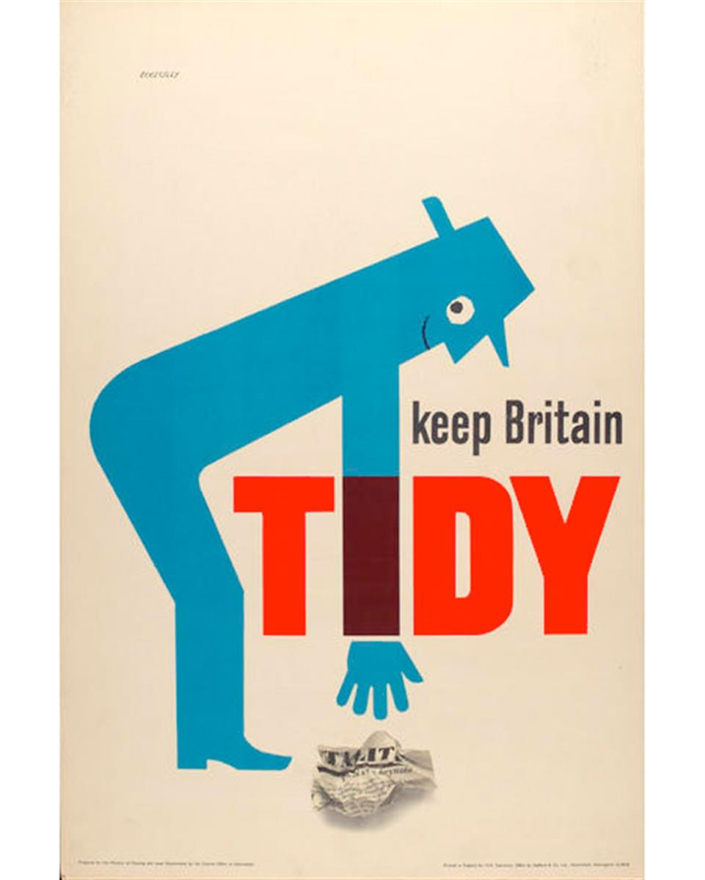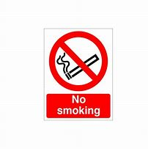
Please do not smoke or drop litter in our Carparks!!
We have evidence of patients smoking and dropping cigarettes and litter in both Spring Hill and Galley Common Car Parks.

Between July and September the Practice staff been subjected to 15 incidences where patients have been verbally or physically aggressive - CCTV is in operation to prevent crime and ensure patient and staff safety but we are kindly asking patients not to behave in an inappropriate manner. We are here to help you. Abuse is no excuse.
