SPRING HILL MEDICAL CENTRE
NEWS LETTER
JULY 2017 EDITION
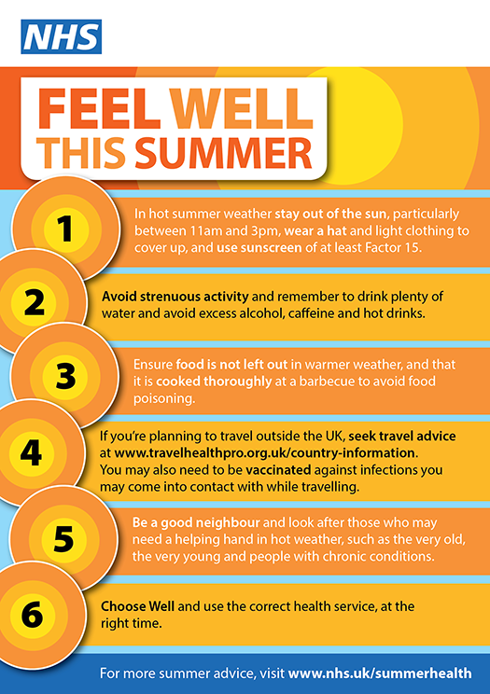
PRACTICE CLOSURE DATES 2017:
19 July at 12.30
20 September at 12.30
18 October at 12.30
15 November at 12.30

