Spring Hill Medical Centre

Patient Participation Group Meeting

Monday 27th March 2017@ 6.30pm

Present: Kathleen Bell, Lynn Bray, Rebecca Cawston, Shirley Climer, Dr Craggs, Chrissy Jones, Vera Robinson, Brian Franklin, Gail Williams

1 Apologies: Joan Allan, Trevor Allan (Chair), Avis Lynch, Oscar Polanski, Margaret Harness, Debbie Foote, Joy Roberts, Jean White

2 Minutes: Approved

3. Matters Arising
New time had been agreed via PPG vote to move the time from 5.30pm to 6.30pm going forward.

Chrissy Jones advised the PPG that due to circumstances Trevor Allan has resigned as PPG Chair. Furthermore due to Mr Allans circumstances at this moment in time Joan Allan will also not be attending any future PPG meetings. Chrissy Jones for and on bahlf of the Partners at Spring Hill wanted to highlight and thank Mr Allan for all his support and dedication throughout his time spent as Chair and wish him the best of health and luck for the future. PPG noted and approved the resignation and thanks Mr Allan for all his hard work.

Chrissy Jones noted that Citizens advice was proving popular with patients and was at Spring Hill on Mondays and Galley Common on Tuesdays.

Chrissy Jones advised the PPG that she has invited HealthWatch Warwickshire to inspect the practice on a date and time which suited. HealthWatch Warwickshire inspected the practice on 13th February 2017. The inspection went very well and Chrissy Jones highlighted the suggestion and responses made by HealthWatch Warwickshire to the PPG:

- The surgery look into the concerns raised by the patients in respect of the appointment booking system. Although the surgery has recently implemented an online booking system, there have been changes to the normal booking system and this appears to have caused problems at busy times. A ‘How To’ guide could assist with the concerns raised by patients.
- Informing patients on the day of any delays which may impact their appointment. Good practice seen at other surgeries has involved a notice board in Reception or the use of the electronic check in or TV system to notify patients of current waiting times.
Suggestions and complaints box be easier to access by placing it in a more visible place in the waiting area.

The Practice response to the suggestions were as follows:

- A guide to the appointment system – In response to patient comments about access to appointments we are making changes to the current appointment system with effect from December 2016. This is a trial and feedback will be monitored and produced in order to consult with our patient participation group and any formal intentions of changes to the clinic appointment system will be communicated. The practice supplied a guide to patients via hard copies (available on reception at both sites) and on our website along with a leaflet during its early implementation in December 2016 and January 2017. Pre bookable appointments with the preferred doctor of choice are available when patients register for on line. Our “Did not attend” (DNA) rate reduced from 182 to 82 under the trial appointment system month on month. Also the practice during March / April 2017 are running a survey on how patients feel the new appointment system is working and asked to provide feedback – at this moment in time the practice have received positive comments
- The Practice main site does have a board detailing which GP’s are on and off duty and should be updated by the receptionist if there are any delays and by how much daily.
- As well as a box - “Suggestions and complaints” are also handed and responded too via our website via share your experience email.
We were sorry to learn of some patients’ experience and can appreciate their frustration. Please be assured that this is not the level of service we would wish for our patients and we take on board all comments from patients and will act upon the feedback provided.

WE WOULD ALSO LIKE TO THANK HEALTHWATCH FOR THEIR SUPPORT AND VALUE THEIR RECOMMENDATIONS.

A copy of the report will be sent prior to Julys PPG meeting for perusal.

4. New Chair and
Deputy Chair of the PPG
Chrissy Jones discussed the recent nominations for a new chair and deputy chair position and confirmed that Gail Willaims had received 3 nominations for the deputy chair. It was approved by the PPG that going forward Chrissy and Gail would work closly together in order to push the PPG agenda forward. The PPG approved the position of deputy Chair to Gail Williams. Gail Williams has been a resident in Arley for many years and is heavily involved with the church, parish council and monthly activities in and around New and Old Arley. Gail Williams will be a great assett to the PPG.

5. New appointment
System Trial Feedback
Chrissy Jones highlighted to members of the PPG that in response to patient comments about access to appointments the practice during December 2016 had been making changes to the current appointment system:

Patients are to call the practice at 8am to make an appointment to be seen THAT DAY by the doctor of choice. The only time patients may not be able to see their preferred doctor is when that doctor is on-call.

Pre bookable appointments are available which can be booked in advance once patients have registered for on line services or patients are to telephone a dedicated member of the team. In addition the practice also offers offer early and late night pre bookable clinics.

Whilst we understand that the appointment system may not suit all patients, we have:

- Seen a significant decrease in our did not attend rates going from 182 from the previous appointment system to 82.

- Reduction in wasted clinic time for Doctors and Nurses

- Reduced pressure on front line staff who are able to offer prompt appointments to patients

The decision by the Partners was to contunue with the trial and collate feedback before any changes can be made.

6. Patient
Questionnaire
Results/action plan

SPRING HILL MEDICAL CENTRE
Arley, Nr Coventry, CV7 8FD
Telephone 01676 540395 Fax 01676 540760
Drs T Dickson, L Craggs, M Obaid and C Shah

Report on the results from the Patient Questionnaire 2017
Presented to the PPG 27th March 2017

With the input from the Patient Participation Group (PPG) deputy chair, the practice redesigned the patient questionnaire for 2017. Patient administration personnel handed it out to patients during January and February 2017 at Spring Hill and the branch site at Galley Common.

Please find below the outcome of the results of the patient questionnaire which was discussed and approved by the PPG members on 27 March 2017 along with the action plan for Spring Hill Medical Centre. It was approved by the PPG that all actions are to be completed by June 2017 and a post meeting report will be produced and distributed to the PPG to confirm in July 2017.

Overall the response from the questionnaire was positive with excellent suggestions from service users for potential additional services for the practice to investigate and develop.

- Did you find the surgery easy to access?
The majority of patient responses found Spring Hill easy to access. The main site based at Arley has adequate parking therefore that is why the majority of medical personal are based there during the working week. The branch surgery should only have 1 GP, 1 Nurse and 1 Receptionist at any time during the working week.

- How comfortable is the waiting area at Spring Hill and our branch surgery at Galley Common?
The majority of patient responses found the waiting areas were excellent to very good. Patients commented that the internal décor in Galley Common needed attention

ACTION: Practice to focus on internal building investment within the branch surgery including new waiting room chairs and windows and also replacement of guttering and facias.

- How easy is it to get an appointment for the time you want for a GP or Nurse?
The majority of patient responses found that it was very easy to get a nurse appointment and fairly easy to get a doctor’s appointment. In response to patient comments about access to appointments, the practice have made changes to the current appointment system with effect from December 2016 this is a trial and feedback will be monitored and produced in order to consult with our patient participation group and any FORMAL intentions of changes to the clinic appointment system will be communicated. The practice is currently running a survery on ease of access for appointments during the trial of the new appointment system, so far the feedback has been very positive and the practice did not attend rates have reduced from 182 to 82 per month.
ACTION: Practice to focus on maximising the use of appointments and focus on DNA patients.

- How do you book your appointments?
The majority of patients booked their appointments via the telephone. The practice has increased is on line books via patient services for patients to pre book appointments to see their preferred GP and Nurse – this is providing very popular and will reduce the influx of telephone calls from patients at 8am and provide patients with the benefit of being able to access the website to make on line appointment bookings and order repeat prescription where ever they are.
ACTION: Further communication campaign on using the internet to make on line appointments.

4b. Are you aware of the different appointments used at the practice; Routine, sit and wait, emergency (to be seen)
The majority of patients understand the appointment system.

- Are you aware of the Practice online system?
The majority of patients are now aware that the practice had a patient online system. The practice has spent a lot of time and effort promoting the on line booking system in house and via the Jayex and website. This has increased from last year’s patient survey results.

- How often do you access the surgery’s website?
The majority of patients accessed the website; this could be due to no internet facility at home or they were no aware of the website address. This has increased from last years’ results.

- Are you aware we can send out information via text messages?
The majority of patients now know that the practice sends out information via text messages. A communication drive on patients updating their contract details will be undertaken in April 2017.

- Are you happy with the continuity of care you receive from Spring Hill Medical Centre – are you able to visit your desired GP or nurse?
The majority of patients were happy with the continuity of care they received from either a GP or Nurse however, the new clinical appointment system trial is a work in progress and does not suit all patients. As highlighted previously a survery is currently being undertaken by the practice to get feedback from the patients on the clinical appointment system and communication will be fed back to the PPG accordingly.

- Are you happy with the care provided at your local hospital?
Please circle your local hospital:
George Elliott/University Hospitals Coventry & Warwick/Heartlands /other
The majority of patients were happy with care received but the practice will be looking into other patients comments about the poor care they have received (in confidence) and report back to the clinical commissioning group accordingly.
ACTION: Practice to communicate with CCG re: poor patient care at hospitals.

- Are you aware the surgery offers the following services?
Ear Syringe, ECG, 24hr BP Monitor,Spirometry, Minor operations, Cervical Smears, Asthma check, Liquid Nitrogen, Dressings, Certain Injections.
The majority of patients knew about additional services that the Practice provided.

- The Practice is keen to ensure it is providing the services its patients require. Is there a service you would like us to provide?
Patients have suggested the following services be brought into a Primary Care setting:
- Additional Phlebotomy services
- Baby weight clinics

- Overall how satisfied are you with the practice?
Overall the majority of patients were very or fairly satisfied with the Practice. The practice received positive comments such as excellent service. The new appointment system is brilliant as I was seen on the day. Furthermore, the practice is working with Carers Corner and North Warwickshire County Council on pilot projects. The practice is also involved in a piece of work with external agencies, locality team and the clinical commissioning group to provide additional community services to patients.

The practice did received negative comments from patients on:
- Not being able to make a routine appointment,
- The length of wait on the telephone,
- No appointments as they are always gone at 8.15am,
- Patients cannot ring up at 8am for an appointment as they are at work and when they are booked for an emergency (to be seen) appointment the length of time it takes to be seen
- Only one female doctor. (Patients would like appointments with the female doctor to be made available each day for ‘female concerns’ so that they can be seen by a female doctor and not on an emergency appointment due to no routine appointments available).

The partners and business manager will be looking into addressing (where at all possible) these comments on the areas of service the practice provides for its patients with focus on constantly reviewing processes and providing excellent management of care to its practice population.

ACTION: Partners to consider the trial appointment system.
ACTION: Partners to consider pre bookable appointments with the female doctor for female patients each day.

All results and actions have been agreed by the PPG.

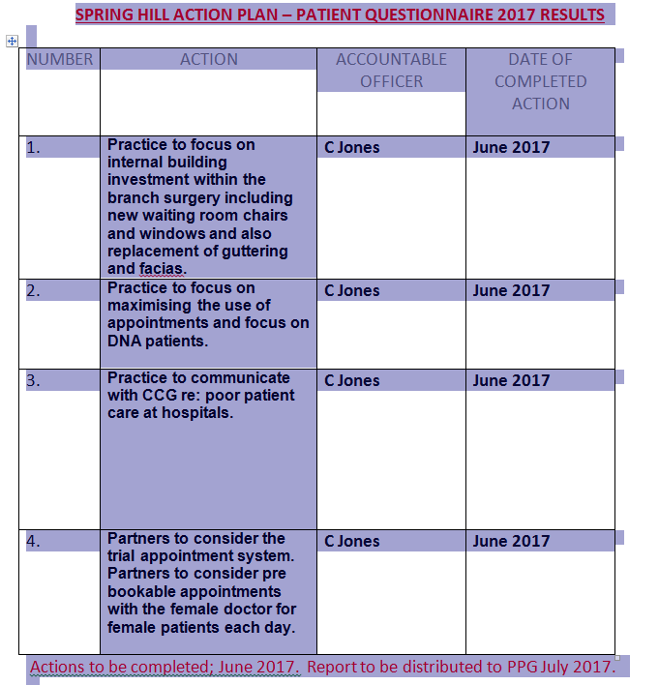

6. AOB Chrissy Jones highlighted the following under any other business:

- Acute (Hospitals) discharging patients without any care package in place. Chrissy Jones highlighted that the practice are aware of patients and we are highlighting this to the CCG. The practice is working very closley to ensure no patient is discharged without the adequate package of care in place.
- Chrissy Jones noted that AGE UK is still working with the practice and it has been very beneficial to patients.
- Chrissy Jones advised PPG members that herself and Gail Williams undertook part of Old Arley for the Arley Door knocking campaign in conjunction with North Warwickshire County Council and further results would be communicated on the website.
- Chrissy Jones highlighted that extensive work had been undertaken with regards to the website http://www.springhillmedicalcentre.co.uk/ and more information is available for patients including practice news which also provides details for other agencies which patients may find useful.

7. Next Meeting
Monday 17th July 6:30 at the Surgery. ** Date cancelled and re-booked for 27th Nvember at 6.30pm.

